incubator
Make-'sandy Scientific’

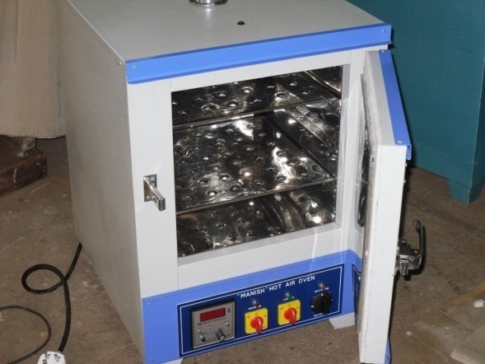

Construction: It is Double walled construction. Inner chamber made of 304 grade stainless steel. Outer chamber is made of Mild steel (Tata make) made of attractive finished in powder coating for durable operation. Inner chamber is fabricated with ribs to adjust trays to any convenient height. Oven supplied with removable perforated trays 2 or 3 depending on sizes. Trays are made of stainless steel.

Insulation: It insulated by 3” gap between the walls is filled with special grade wool for proper insulation and to avoid heat losses.

Door: It is double walled inner Stainless steel and outer chamber mild steel with powder coated paint fitted with heavy stainless steel hinges with spring loaded lock and avoid Heat loses to fixing felt on the door.

Heating elements: Heating elements are made of high-grade Nichrome wire, which are put ixnside the porcelain beads and placed at bottom and two vertical sides for uniform temperature all over the space.

Temperature Control: The temperature is controlled by SelecDigital Temperature Controller to view set value and processing value and set timer also .variable from above ambient to 60 deg celsius with a sensitivity of +/-2 º C.

Ventilation: Air ventilators are provided top at as well as the bottom to ventilate gases and fumes if any.

Control Panel: The equipment is provided with a panel which is just below the door having a Digital Temperature Controller with timer ,safety Mcb Tripper Switch On/Off switch, main on/off Indication LED lamp and Heat indication ON/off Led Lamp Fan on/off sitch L&t ,Heater On/off L&t switch.

Power Requirement: Supplied with cord and plug, Suitable to operate on 220V as per indicator single phase, 50 Hz AC supply.

Including
1. Digital temperature Indicator-com –controller with timer and rtd-type Sensor
2. Air circulating fan Assembly in Back side of the chamber

Inner Chamber | No. of Shelves | Rating
W x H x D | No. of Shelves | Rating
350 x 350 x 350mm | 1No. | 50Kw
450 x 450 x 450mm | 2No. | 60Kw
450 x 600 x 450mm | 3No. | 80Kw
600 x 600 x 600mm | 3No. | 1Kw
600 x 900 x 600mm | 3No. | 1.2 Kw

